Name  Stephen  Maria  Elisa  Sabrya | Frequency adverb  always  never  sometimes  usually | Verb phrase  goes to  goes to  goes to  goes to | Noun phrase  the hairdressers  the butchers  the florist  the cake shop

Choose people and write sentences in present simple tense.

 | Noun | frequency adverb | verb phrase | noun phrase
 | Jennifer | always | goes to | the hairdressers.

Noun  Jennifer  Elisa  Ali  Regat | Verb phrase  is going to  is going to  is going to  is going to | Noun phrase  the butchers  the clothing stall  the book shop  the market

Choose people and write sentences in present continuous tense.

 | Noun | verb phrase | noun phrase
 | Stephen | is going to | the hairdressers.

 | mother | daughter | sister | wife
 | father | son | brother | husband
plural | parents | children | brothers / sisters | husbands / wives

Sally = Tom

Kirsty Nick

Complete:

Sally is Tom’s | wife. | Tom is Sally’s
Kirsty is Sally and Tom’s |  | Nick is their
Sally is Nick’s |  | Tom is Kirsty’s
Kirsty is Nick’s |  | Nick is Kirsty’s
Sally and Tom are Kirsty and Nick’s |  | Kirsty and Nick are Tom and Sally’s

Wife children parents father mother brother sister

Emotions
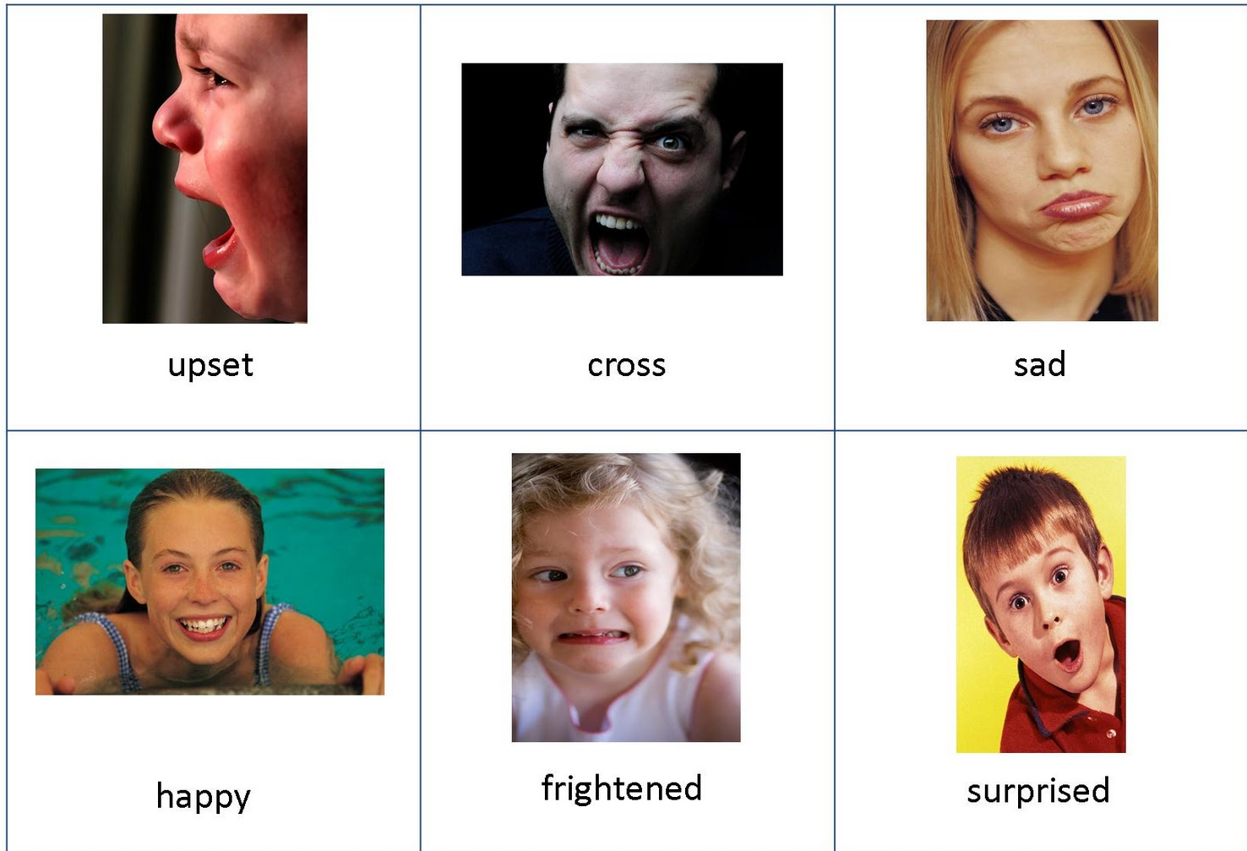
surprised
scared
happy
sad
angry
upset

1.) Write the 6 emotions and discuss “I feel ….” “We feel …”
pronoun | noun | pronoun | noun
I am | surprised. | I’m | surprised.
He is
She is
You are
We are
They are

3.) Write the missing pronouns and nouns using the negative contracted form.
pronoun |  | pronoun |  | pronoun
I am not | surprised. | I’m not | surprised.
He is not | upset. | He’s not | upset. | He isn’t | upset.
She is not | angry. |  | angry. |  | angry.
You are not | sad. |  | sad. |  | sad.
We are not | happy. |  | happy. |  | happy.
They are not | scared. |  | scared. |  | scared.

4.) Ask each other questions and use the negative contractions above.
question | answers
How are you? | I’m not surprised.
How is he? | He isn’t upset.
How is she?
How are we?
How are they?

